- OVERVIEW :
Client Server Communication:-
caB2B client is a standalone Java Swing application and caB2B server is a J2EE server deployed on JBoss. Client- server communication happens through RMI-IIOP (see Appendix). EJB (Enterprise Java Beans) is a part of Java RMI-IIOP i.e. EJB is a remote object and is callable from different JVMs. During server startup each EJB’s Home Object (i.e. factory for creating EJB instances) is tied with a name in JNDI (see Appendix) tree on the same server. When client needs to call a method on server side code, it does following:

- It asks EJB-locator on client side to locate appropriate EJB instance (in the form of Business Interface) that provides the required functionality. Each locator instance is aware of which JNDI tree to refer.
- Locator looks up the Home Object of corresponding EJB in JNDI tree and uses it to get EJB instance.
- The client then calls the required method on BusinessInterface.

- CLASS DIAGRAM:

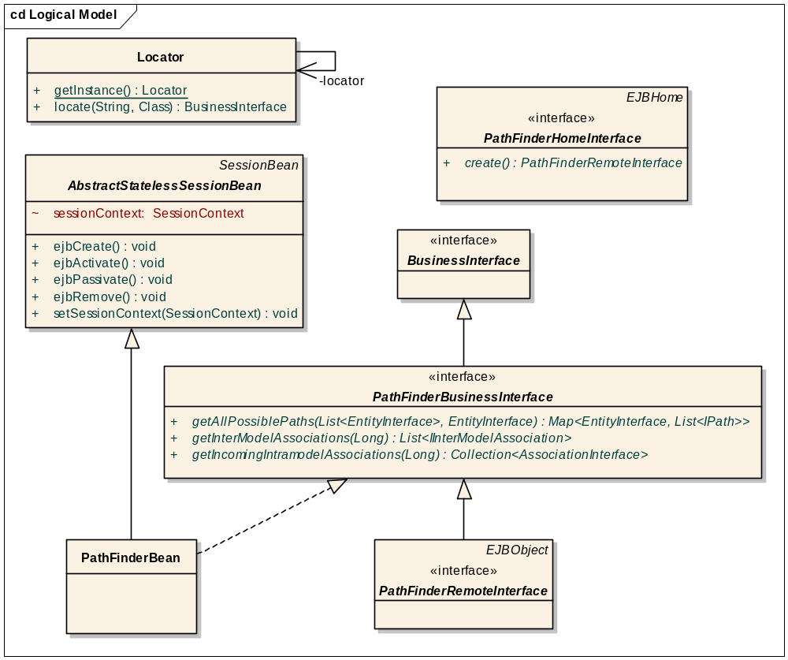
Class diagram of EJB (e.g. PathFinderBean)

- SEQUENCE DIAGRAM:
The following sequence diagram describes a sample flow of EJB lookup remotely:

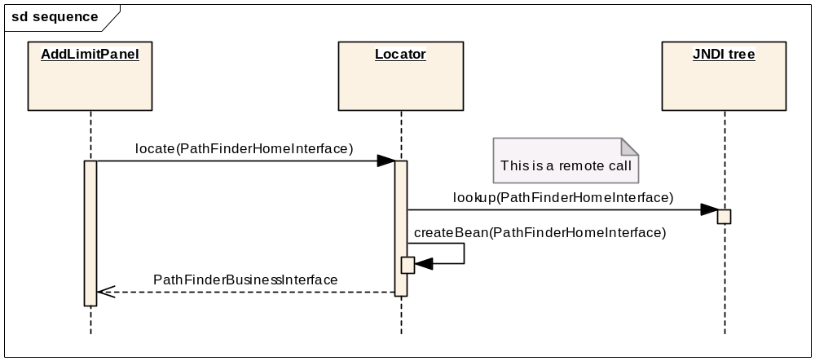
Consider a case where UI needs to find paths between two entities.
The flow of events will be as follows (refer class diagram above):

- There will be a PathFinderBusinessInterface with method
getAllPossiblePaths(Source, Destination). It returns list of Paths.
- There will be an EJB, PathFinderBean, which implements PathFinderBusinessInterface.
- Home interface of the EJB will be PathFinderHomeInterface. EJB’s remote interface i.e PathFinderRemoteInteface will extend PathFinderBusinessInterface.
- UI will call locator to find appropriate class for finding paths. Locator will lookup the PathFinderHomeInterface from JNDI tree and will call create () on it which returns PathFinderBusinessInterface. Then it will return the PathFinderBusinessInterface to UI.
- UI will call getAllPossiblePaths(Source, Destination) on PathFinderBusinessInterfaceI to get list of Paths.

- Appendix
RMI-IIOP: Remote Method Invocation over the Internet Inter-ORB Protocol
http://java.sun.com/j2se/1.5.0/docs/guide/rmi-iiop/
http://java.sun.com/products/rmi-iiop/

JNDI: Java Naming and directory interface
http://java.sun.com/products/jndi/
http://java.sun.com/j2se/1.5.0/docs/guide/jndi/index.html

